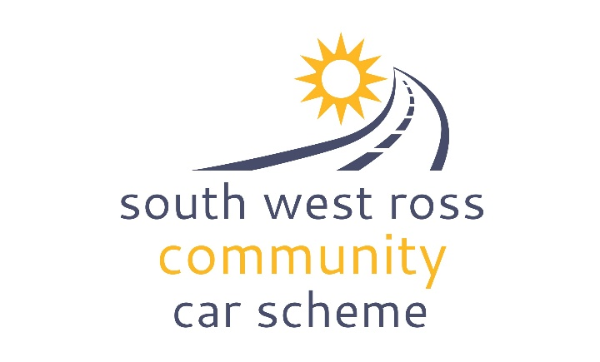
Membership Application Form

Please complete in BLOCK CAPITALS

Personal Details | Membership
Name: | Membership of SWRCCS shows your support for the organisation and means that we will keep you in touch with what we do.
Address | Voting membership will enable you to have your say at Annual General Meetings and get more involved with the organisation.  All members are approved by the Board of Trustees
Postcode | I wish to become a member of SWRCCS: (please highlight one)
Phone | Voting member:  Individual / Associate
Mobile | Non- Voting Member  Individual / Associate / Junior
Email | If Associate, which organisation or group are you representing:
Preferred way of contact please delete as appropriate:  Phone Mobile Email | Signature from organisation:
DATA PROTECTION ACT 1998 (the Act) - The information you have supplied will be used for the purpose for which you have provided it and any relevant procedures following from this. This data will be maintained in accordance with the Act and will not be passed on or sold to any other organisation without your prior approval unless this is a legal requirement.
I agree / do not agree to the information I have given being held on the South West Ross Community Car Scheme’s computer database. (Please delete as applicable)

I wish to become a member of SWRCCS and will abide by its constitution, policies and procedures.
I agree to inform SWRCCS of any changes to the above information.

Signed: Date:

Please sign and return this application form to: Peter Fenton, Coordinator, SWRCCS, Loch Torridon Community Centre, Achnasheen IV22 2EZ email: coordinator@swrc-carscheme.co.uk

